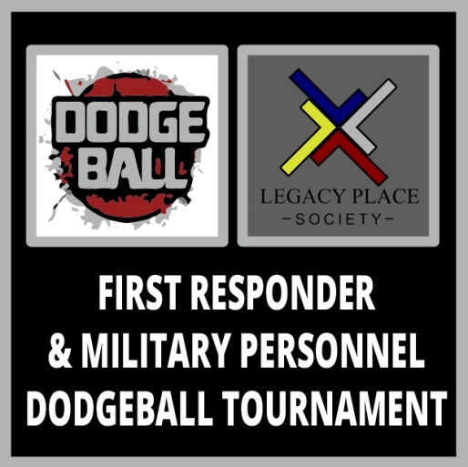 | What are the pledges for?  The funds raised through the  2018 Dodge Ball Tournament  February 1, 2018 event will support parent and children of First Responders & Military Personnel outreach initiatives with Legacy Place Society  www.legacyplacesociety.com | Mailing address is:  Legacy Place Society  2018 Dodge Ball Tournament  BVPO Box 20194 Calgary, AB T2P 4L2  Contact:  Eyvi Smith email  eyvi.smith@rcmp-grc.gc.ca  Diana Festejo (403-201-9945)  Email info@legacyplacesociety.com

Legacy Place Society –is a Canadian registered charity that serves to strengthen First Responders and Military families to withstand the challenges of their profession within the community they serve. Charity # 891549420RR0001
Tax receipts will be issued for donations with complete donor information (full name, address, postal code, phone number).
Cheques must be made out to Legacy Place Society. All tax receipts will be issued from Legacy Place Society.

Collector’s Name:
Address: Email:
Phone: Postal Code: City/Province: Total Funds Collected: $_

PLEASE PRINT CLEARLY AND INCLUDE ALL INFORMATION SO WE CAN SEND OUT TAX RECEIPTS – THANK YOU

Donor Information |  |  | Amount | Paid | Confirm at hand in
Name (first, last) | Phone # | Cash___ Chq ___#_____
Address | P/C
Name (first, last) | Phone # | Cash___ Chq ___#_____
Address | P/C
Name (first, last) | Phone # | Cash___ Chq ___#_____
Address | P/C
Name (first, last) | Phone # | Cash___ Chq ___#_____
Address | P/C
Name (first, last) | Phone # | Cash___ Chq ___#_____
Address | P/C
Name (first, last) | Phone # | Cash___ Chq ___#_____
Address | P/C
Name (first, last) | Phone # | Cash___ Chq ___#_____
Address | P/C

